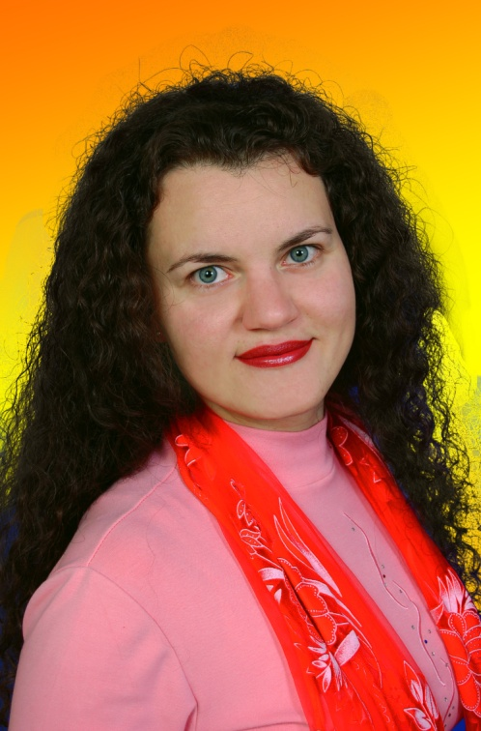  Name: Hanna  Surname: Sheldagayeva (Petrenko)  Date of Birth: 06.02.1979 | - EDUCATION: Kherson State Pedagogical University (2001); British Council and IATEFL Summer School “Train the Trainer” 36-hour course (2013); Kherson Academy of Continuing Education (regular courses: 2006, 2011)  - PLACE OF WORK: Kherson Classic School # 6 (since 2001)  - CURRENT POSITION: Teacher of English as a Foreign Language (14 years of experience ), Head of the School Methodological Union (since 2013)  - OTHER RESPONSIBILITIES: Freelance EFL Instructor at Kherson Academy of Continuing Education (since 2012) – Insett Component: Mistakes Management; Workshop conducted: Teaching Literature as Communication  - METHODOLOGICAL BROCHURES PUBLISHED: Tests in English and American Literature for High School Pupils (2014); Methodological Recommendations for Teaching English and American Literature (2014)  - ARTICLES PUBLISHED: The Criteria for Selecting Literary Works to Study in Class; Teaching Literature as a Means of Intercultural Communication  - MEMBERSHIPS: Member of the Ukrainian Congress of Writers; Member of the Ukrainian Interregional Union of Writers (IUWU)  - COLLECTIONS OF POETRY PUBLISHED: «Воскресшая…» (2000), «По ту сторону суеты…» (2004) [Both in Russian]  - CURRENT ACTIVITY: getting published the Cultural Reader “Kherson’s Special Sun-Dial Time”, one of the world’s top seven cultural readers in 2013 (Macmillan Education Competition 2013) compiled and edited by Hanna O. Sheldagayeva

